**MALALA YOUSAFZAI**

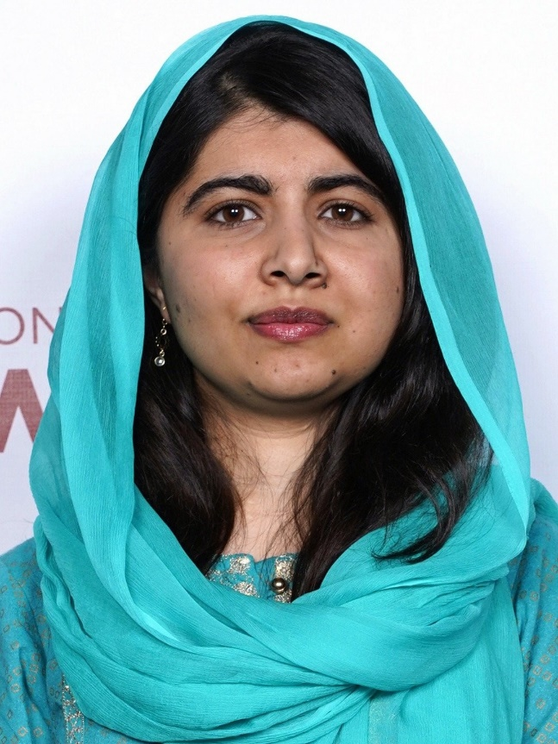

**Malala Yousafzai was born on July 12, 1997, in Mingora, the largest city in the Swat Valley in what is now the Khyber Pakhtunkhwa Province of Pakistan. The Taliban began to control the Swat Valley and quickly became the dominant socio-political force throughout much of northwestern Pakistan. Girls were banned from attending school, and cultural activities.**

**Determined to go to school and with a firm belief in her right to an education, Malala stood up to the Taliban. Her activism resulted in a nomination for the International Children’s Peace Prize in 2011. That same year, she was awarded Pakistan’s National Youth Peace Prize. For her activism, on the morning of October 9, 2012, 15-year-old Malala Yousafzai was shot by the Taliban and was seriously wounded**

**On October 10, 2013, in acknowledgement of her work, the European Parliament awarded Malala the prestigious Sakharov Prize for Freedom of Thought. In October 2014, Malala, along with Indian children’s rights activist Kailash Satyarthi, was named a Nobel Peace Prize winner. At age 17, she became the youngest person to receive this prize.**

**Today, through the Malala Fund and with her own voice, Malala Yousafzai remains a staunch advocate for the power of education and for girls to become agents of change in their communities.**